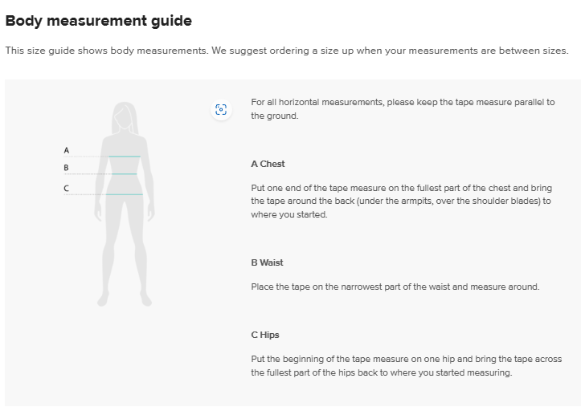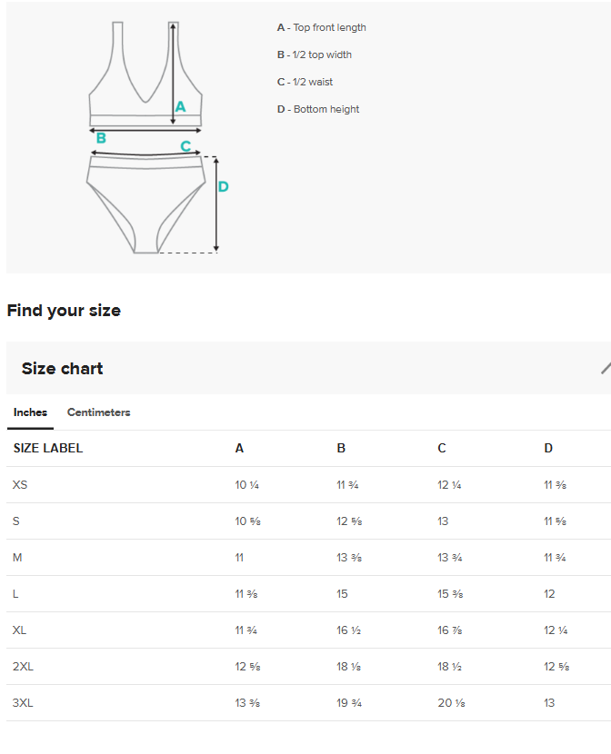

Product measurements
This size guide shows product measurements taken when products are laid flat. Actual product measurements may vary by up to 1" because they’re custom-made by hand.
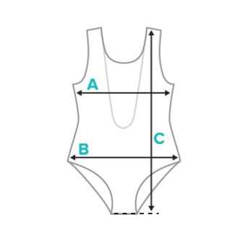
A 1/2 chest width
B 1/2 hip width
C le
