Body measurement guide
This size guide shows body measurements. We suggest ordering a size up when your measurements are between sizes.
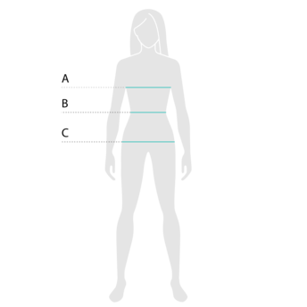
For all horizontal measurements, please keep the tape measure parallel to the ground.

A Chest
Put one end of the tape measure on the fullest part of the chest and bring the tape around the back (under the armpits, over the shoulder blades) to where you started.

B Waist
Place the tape on the narrowest part of the waist and measure around.

C Hips
Put the beginning of the tape measure on one hip and bring the tape across the fullest part of the hips back to where you started measuring.

Find your size

Size chart
SIZE | CHEST | WAIST | HIPS
2XS | 31 ½ | 23 ⅝ | 33 ⅞
XS | 33 ⅛ | 25 ¼ | 35 ⅜
S | 34 ⅝ | 26 ¾ | 37
M | 36 ¼ | 28 ⅜ | 38 ⅝
L | 39 ⅜ | 31 ½ | 41 ¾
XL | 42 ½ | 34 ⅝ | 44 ⅞
2XL | 45 ⅝ | 37 ¾ | 48
3XL | 48 ⅞ | 41 | 51 ⅛
4XL | 52 | 44 ⅛ | 54 ⅜
5XL | 55 ⅛ | 47 ¼ | 57 ½
6XL | 58 ¼ | 50 ⅜ | 60 ⅝

